  Date | AM 1 | AM 2 | PM 1 | PM 2
  *It’s okay if you forget to take a couple of readings*
  Average BP:
  Contact Us
  Burnfield Medical Practice
  Harris Road
  Inverness
  IV2 3PF
  Phone: 01463 220077
  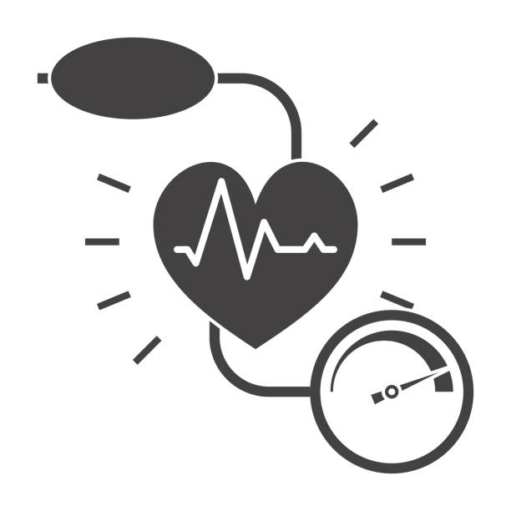
  HOW TO MONITOR YOUR BLOOD PRESSURE AT HOME
  Return Date:
  Patient label here
  Monitor No: ……………………………
  Reason: ………………………………............................................................
  Return form to P/N
  Return form to GP

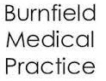
Blood Pressure  WHAT IS BLOOD PRESSURE?  Blood pressure (or BP) is the pressure of blood in your arteries (blood vessels). Blood pressure is measured in millimeters of mercury (mmHg). Your BP is recorded as two figures, for example 150/95 mmHg. This is said as 150 over 95.  - The top (first) number is systolic pressure. This is the pressure in the arteries where the heart contracts.  - The bottom (second) number is the diastolic pressure. This is the pressure in the arteries when the heart rests between each heart beat.  WHY DO HOME MONITORING?  Recent studies suggest that patients doing their BP at home allow a better estimate of true BP.  HOW TO SELF-MONITOR BLOOD PRESSURE?  You will record your Blood Pressure over 7 days in the afternoon, 2 readings in the morning and 2 readings in the afternoon.  - Position yourself at a table with forearm resting comfortably at about heart level  - Sit for 5 minutes before taking a reading  - Don’t cross your legs or talk as this significantly increases your BP  - You may use either arm to measure your blood pressure  - Wrap the cuff snugly around the upper arm (as shown), against bare skin, be certain sleeves are not tight if rolled up  - Take 2 readings in the morning at least 5 minutes apart  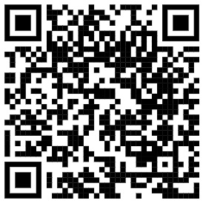  - Take 2 readings in the afternoon at least 5 minutes apart |  |  | June 2022
  Record the results on the table on the back of this leaflet.
  Once you have completed 7 days of monitoring please return the whole leaflet to the surgery.
  The doctor or nurse will look at your results, after 3 days please phone reception for results and any follow up advice.
  LIFESTYLE CHANGES TO LOWER BLOOD PRESSURE
  - Stop smoking
  - Lose weight
  - Exercise regularly
  - Cut down on alcohol
  - Eat a healthy varied diet
  - Reduce salt intake to less than 6g a day
  Scan the QR code to watch a video on how to take your blood pressure.


